Table of Contents

1. Screenshots
   1. Scholar Side(Front End)
      1. Log In
      2. Home
      3. Calendar
      4. Scholar Details(for module 2 only)
         1. Tuition Fee
         2. Grades
         3. Stipend and Benefits
         4. Part Time Job
      5. Contact SM
   2. SM Admin Side(Back End)
      1. Calendar
      2. List of All Scholars
      3. Enrollment Approval/Submission Tab
      4. Set Tuition Fee Tab
      5. Grades Approval/Submission Tab
      6. Benefits Tab
2. Screenshots
   1. Scholar Side(Front End)
      1. Log In

Login Page for SM Scholar

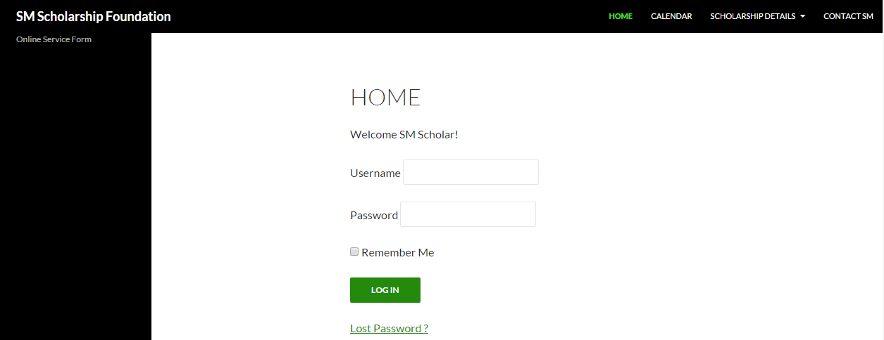

* + 1. Home

Welcome/Home Screen for the SM Scholar

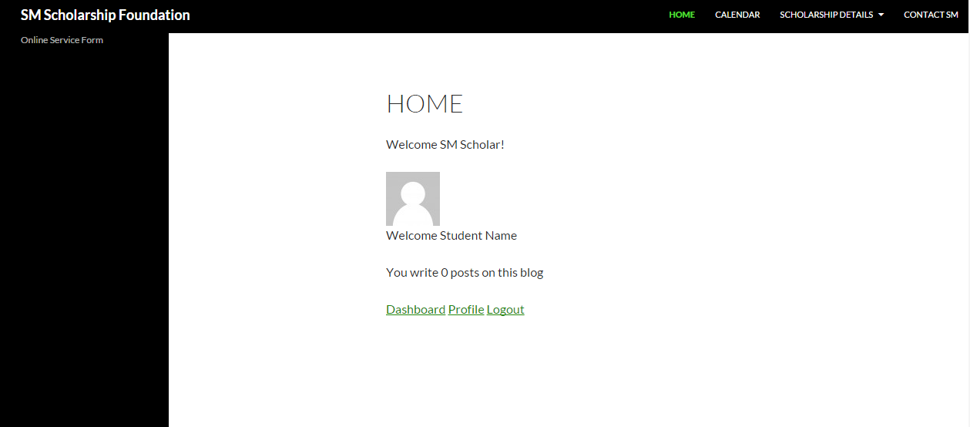

* + 1. Calendar

Calendar Reminder

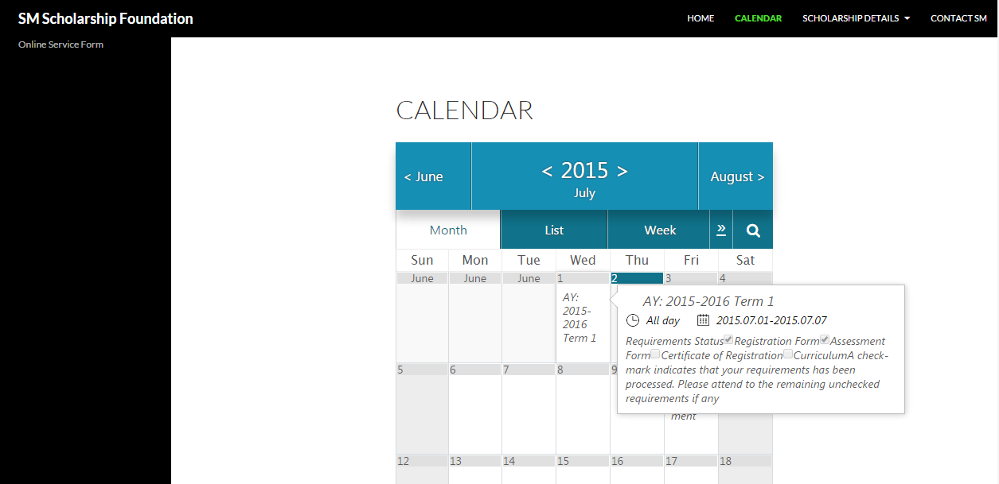

* + 1. Scholar Details(for module 2 only)
       1. Tuition Fee

Upload Registration Form

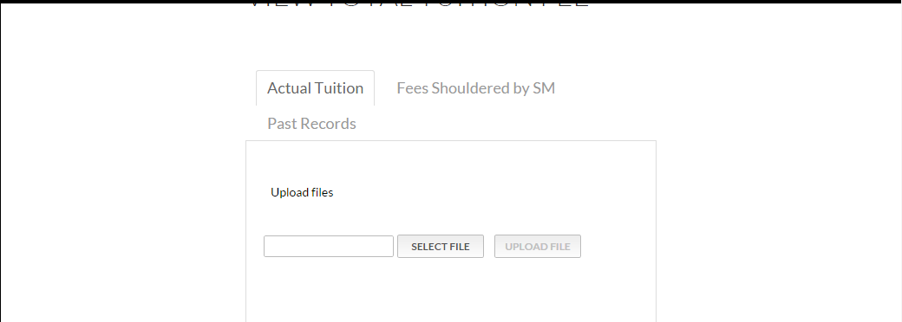

Actual Tuition Fee shown after the Registration form is approved

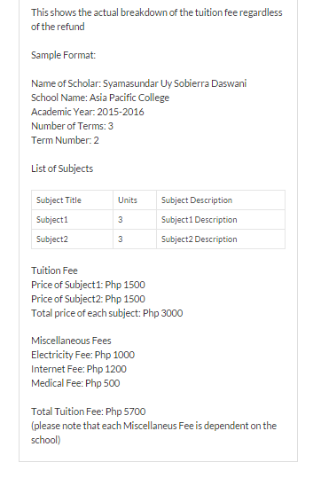

Fees paid by the SM Foundation

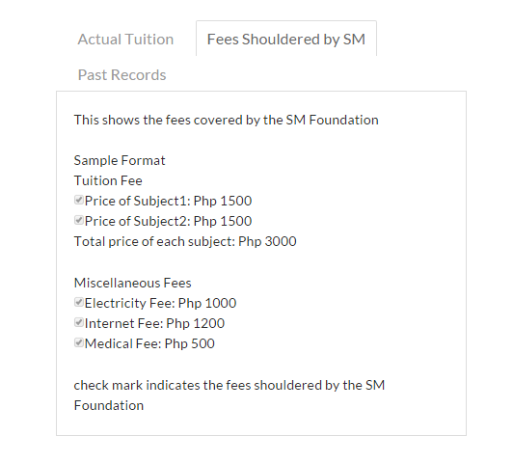

Past Records of the scholar’s Tuition Fee

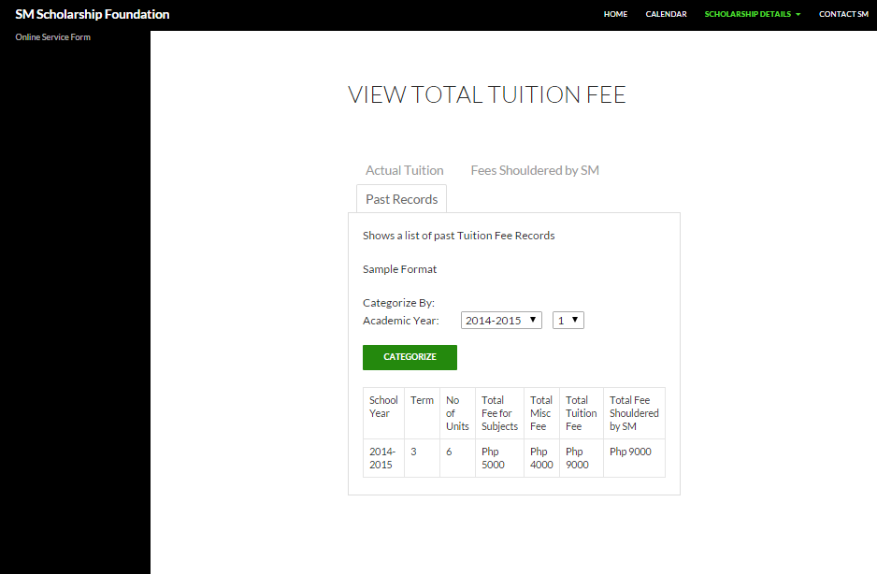

* + - 1. Grades

Upload Grades Online

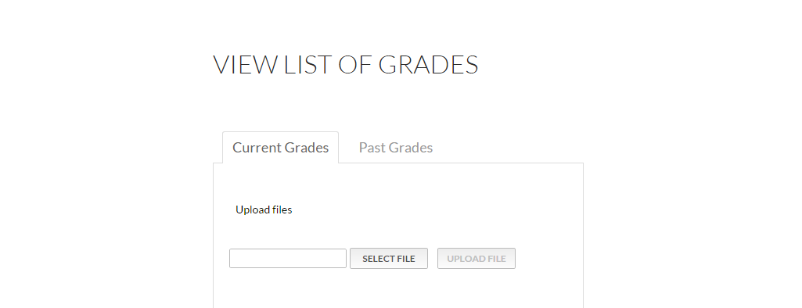

Shown Grades After Approval by the SM Foundation

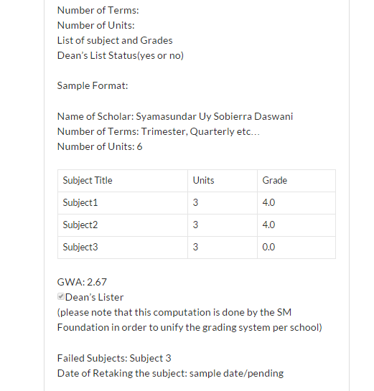

If Grades fall below 2.5

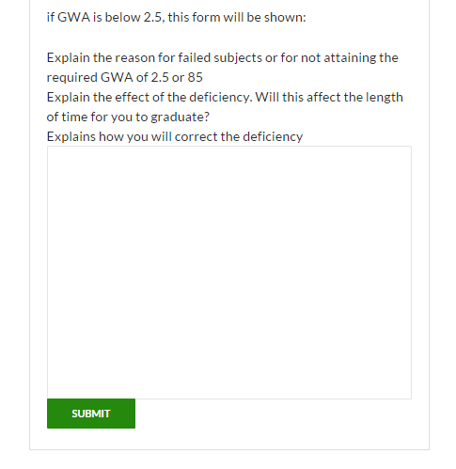

Past Grades

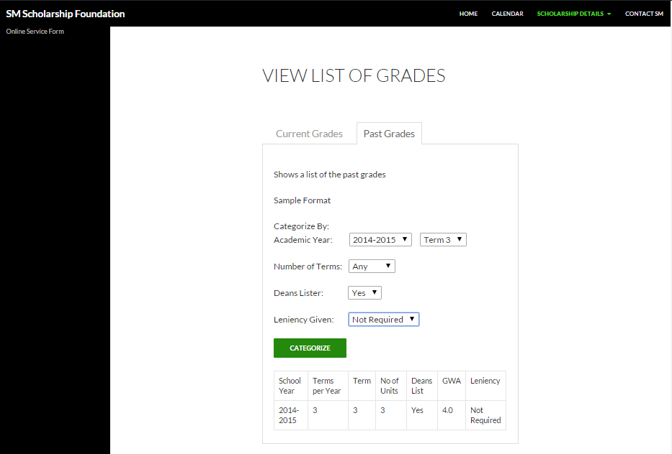

* + - 1. Stipend and Benefits

Overview of the next/current stipend to be received

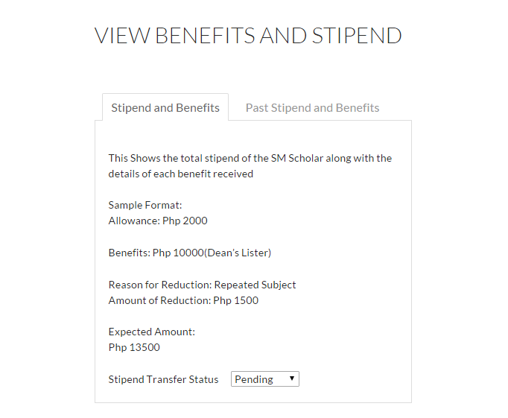

Past Stipends and Benefits

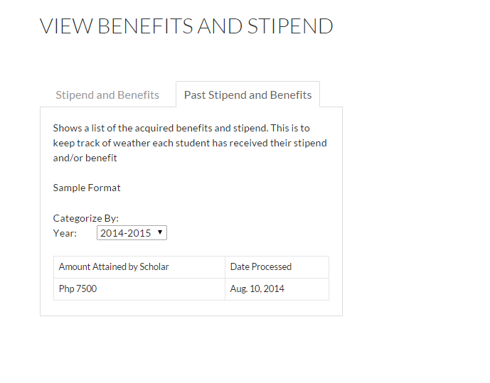

* + - 1. Part Time Job

Creation of a new job form

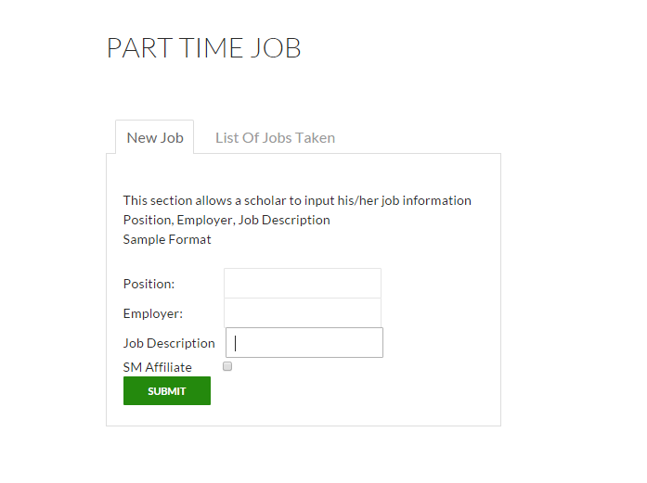

List of Past Jobs

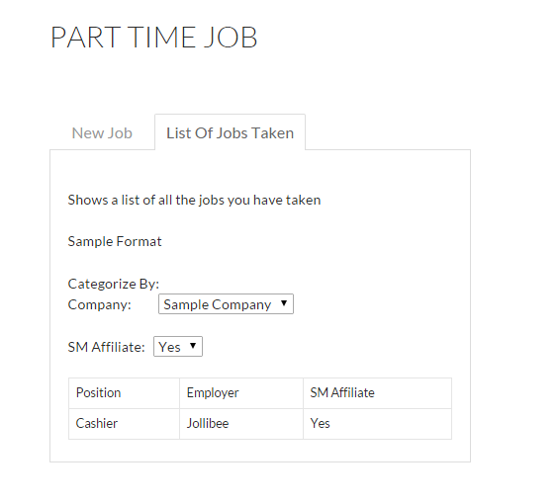

* + 1. Contact SM

Contact SM

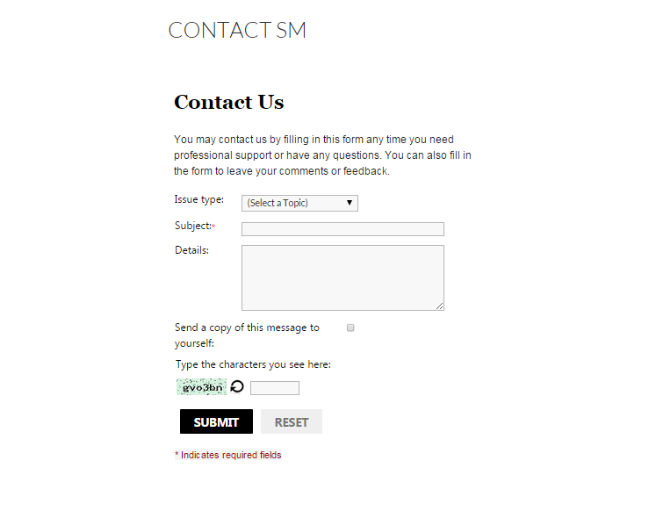

* 1. SM Admin Side(Back End)
     1. Calendar

Calendar widget for all SM Scholars(pending requirements etc…)



* + 1. List of All Scholars

List of SM Scholars with Search

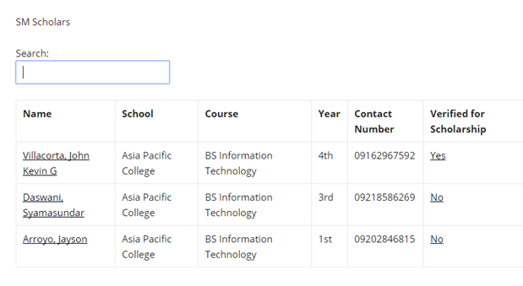

* + 1. Enrollment Approval/Submission Tab

Registration Form Approval/Upload for administrators

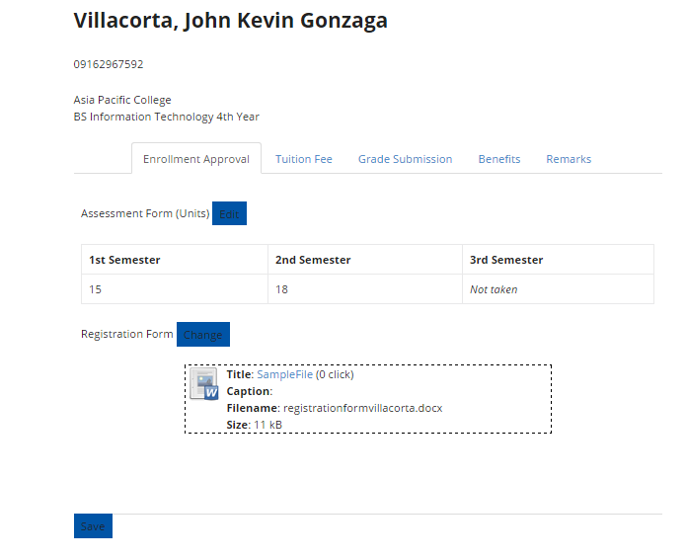

* + 1. Set Tuition Fee Tab

Input the of the tuition fee

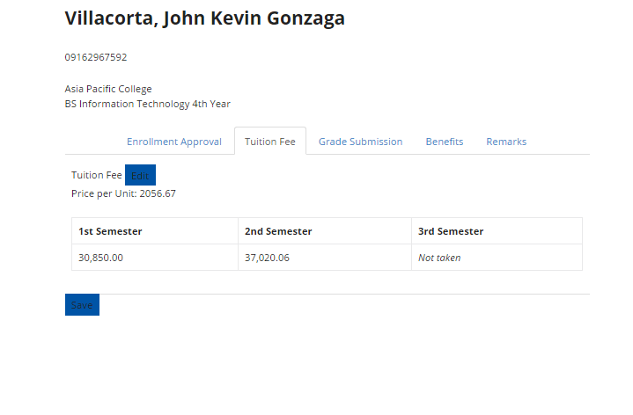

* + 1. Grades Approval/Submission Tab

Upload/Approve submitted grades

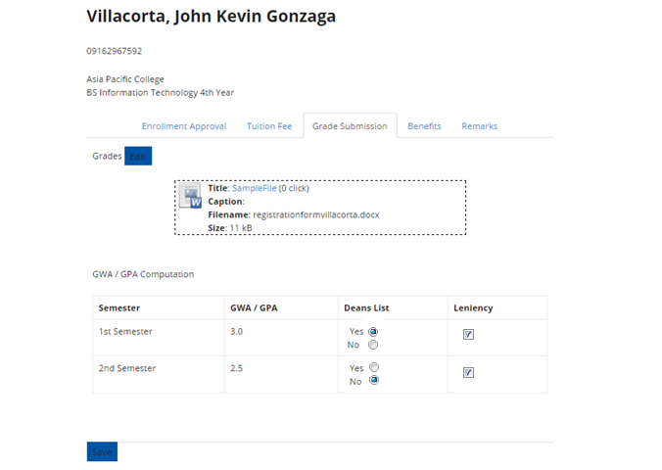

* + 1. Benefits Tab

Shows the benefits of the selected student and the details regarding it

